6-2-2023

ZUNIGA SALVADOR JAVIER ALEJANDRO

hahn software

WEB SYSTEM

Content

WEB Logic 2

Back-end Structure 2

Sequence Diagram 3

DOCKER System 4

Background 5

Functional goals 5

Vitals 5

Optional 5

Desirable 5

Use cases 6

Overall diagram 6

Next level 6

Level to detail 7

F1.1: Create Item 7

F1.2: Read Item 8

F1.3: Update Item 9

F1.4: Delete Item 10

# WEB Logic

# Back-end Structure

# Sequence Diagram



# DOCKER System

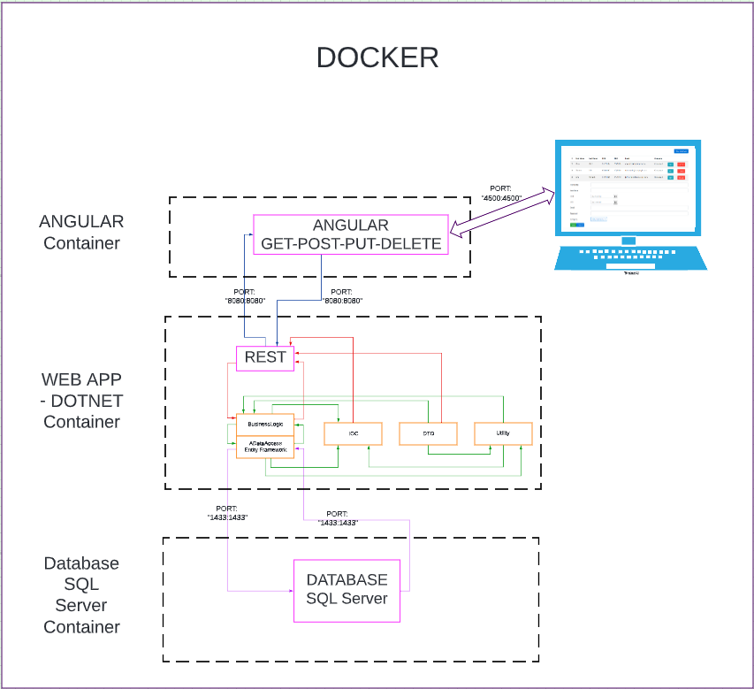

# Background

Within companies it is highly recommended to keep an inventory to know what they have and thus manage their business accurately and without losses, so the implementation of a CRUD to manage the items in an inventory is very necessary.

# Functional goals

## Vitals

* F1: Item Management

## Optional

* F2: User Management

## Desirable

* F5: Sales Management
* F6: Invoice Management

F1:

* + F1.1: Create Item
  + F1.2: Read Item
  + F1.3: Update Item
  + F1.4: Delete Item

# Use cases

# Overall diagram

# Next level

# Level to detail

F1.1: Create Item Items are added to the system database.

Actor: Client

Main flow

1. The actor selects the Add Item button.
2. The system displays Add Item information.
3. The actor enters the id code (Primary Key). (E1)
4. The actor enters item code, item category, item quantity.
5. The actor presses Save.
6. Data is stored in the Database.

Alternate Flow

5. The actor presses Cancel

Exceptions

|  |  |
| --- | --- |
| Cause | Message |
| E1: Database Problems | Item could not be created, Error |

F1.2: Read Item The Actor can consult the items that appear in the system.

Actor: Client

Main flow

1. The system presents the existing items in a table (E1).

Exceptions

|  |  |
| --- | --- |
| Exceptions | Description |
| E1: Problems with the Database | Error loading or presenting data from the database |

F1.3: Update Item The data of an already existing item in the system is modified.

Actor: Client

Main flow

1. The actor selects the Edit Item option.
2. The system displays Edit Item information.
3. The actor enters: Id Code. (E1).
4. The actor may modify:
5. Item Code.
6. Item Name.
7. Category.
8. Item Quantity.
9. The actor presses the Update button.
10. The system updates the item data.

Alternate flow

5. The actor presses the Cancel button.

Exceptions

|  |  |
| --- | --- |
| Cause | Message |
| E1: Database Problems | Item could not be edited, Error |

F1.4: Delete Item The Actor may delete an item from the system.

Actor: Client

Main flow

1. The actor selects Delete button.
2. The system displays Delete Item information.
3. The actor presses Yes, Delete button. (E1)
4. The system deletes the item data.

Alternate flow

1. The actor presses No, Cancel button.

Exceptions

|  |  |
| --- | --- |
| Cause | Message |
| E1: Database Problems | Item could not be deleted, Error |

Planning

Item Management, where the C.R.U.D of Items will be generated and developed, the client will control and manage the item management. Backend developed with n-tiers(layers) architecture.